Implement virtualization using Hyper-V

Steps involved how to - Implement virtualization Hyper-V below in the following order
Step 1 - First we have to uninstall vmware software if already installed on computer because the VMware Workstation installer does not support running on a Hyper-V virtual machine.
After uninstalling VMware, we can proceed to next step - go to control panel and click on uninstall a program.
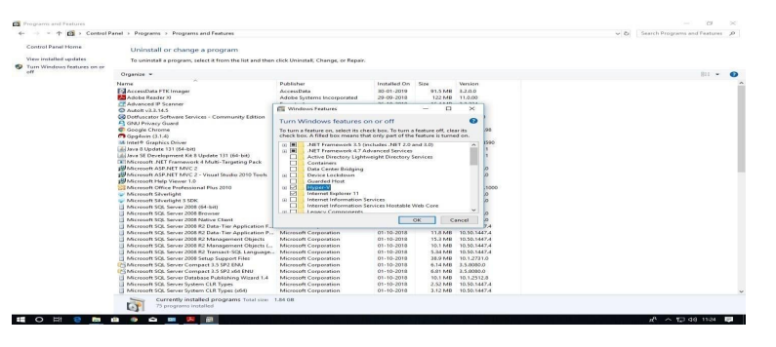
Step 2 - If Hyper V is not installed and if you couldn’t find it then follow the link to do installation.
https://www.how2shout.com/how-to/how-to-download-and-install-hyper-v-on-windows-11- home.html

- Steps to download & install Hyper-V on Windows 11 Home –

1. Create a text file -
Right-click on your Desktop and select New and then Text Document to create a new empty file.
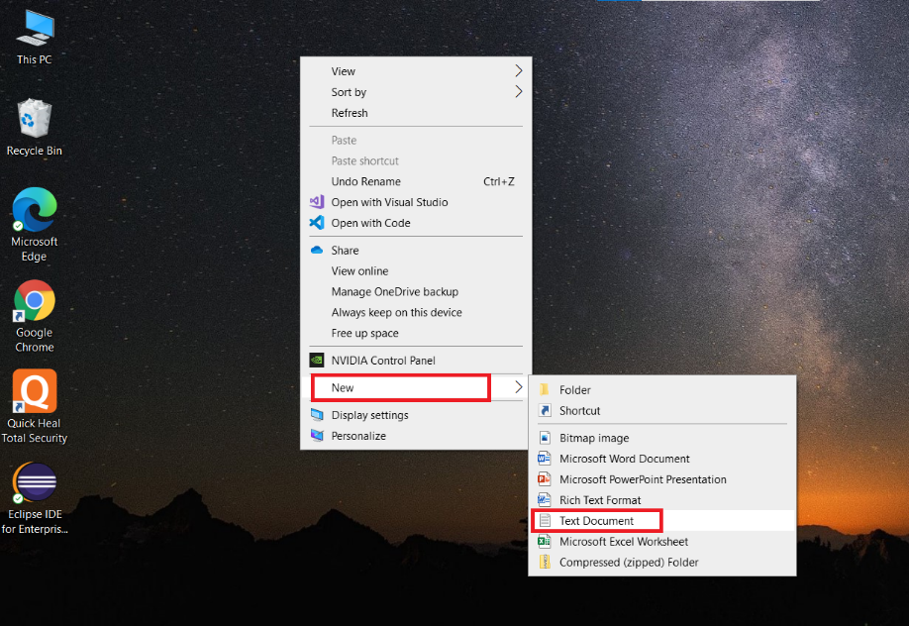
2. Bat file code to download Hyper-v for Windows 11 home -
Next, open the newly created file and paste the following given code into it.

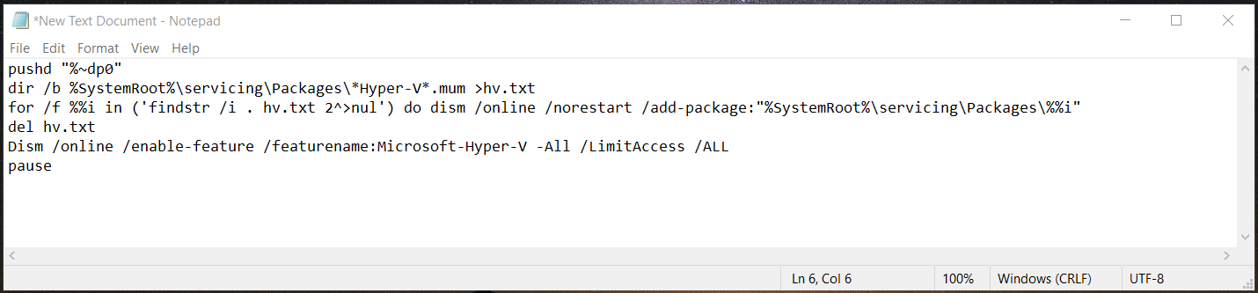

After that click on the File option given in the menu and select the “Save As…” option. Before saving assign it a name- hyper.bat

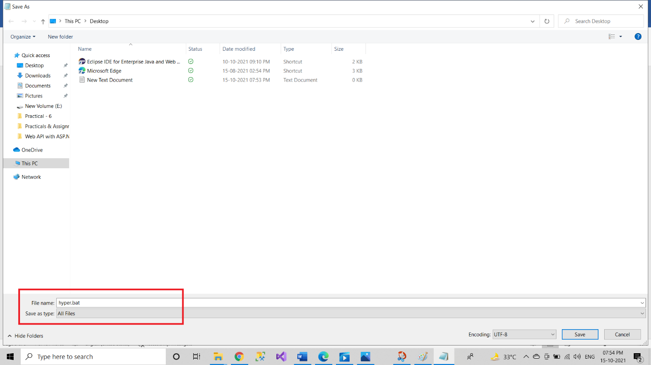

3. Run script to install Hyper-V -
Once you have the BAT file on your system, right-click on it and select the
“Run as Administrator” option.
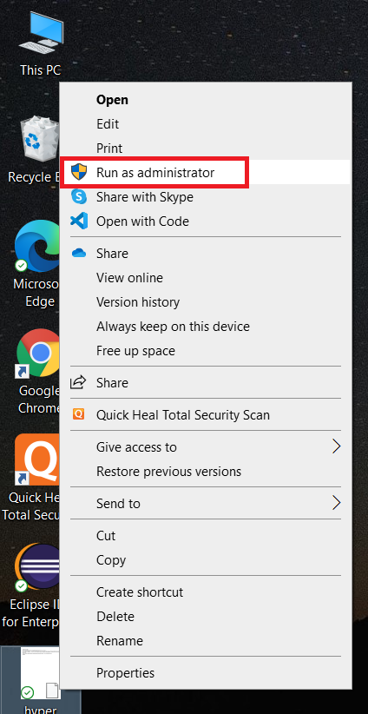

5. You will see a process will get started on your Command prompt to download the packages for Microsoft Hyper-V Services for Windows 10 home. Wait until that is not get completed, once it is done, press Y and hit the Enter key to restart the system.

Note: Now you can delete the created hyper.bat file.
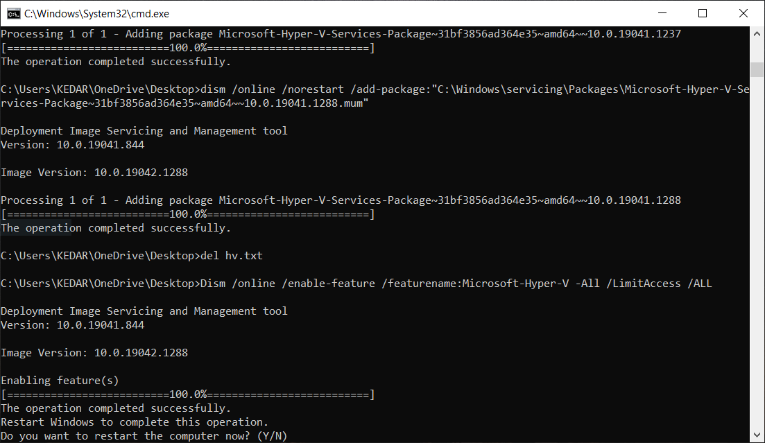

6. Start Win 11 Microsoft Hypervisor platform -
Click on the Start button and type- hyper, soon you will see the “hyper-V Manager” icon. Click it to run the same.

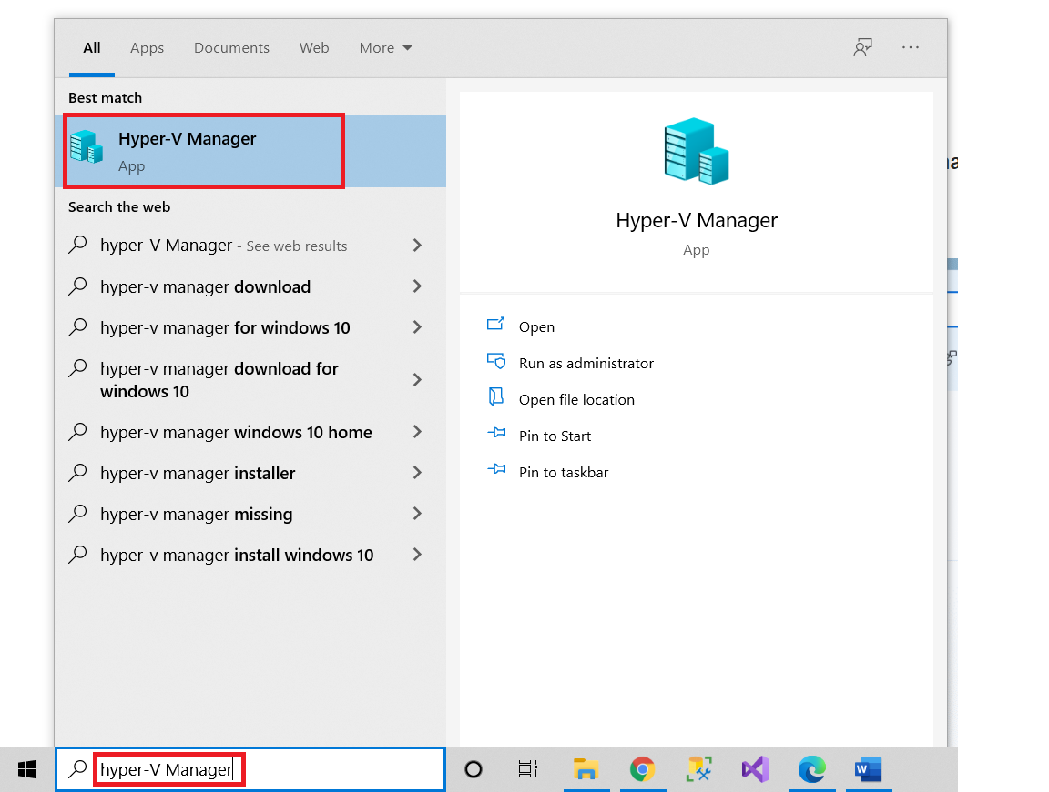
Step 3 - After Restart Search for hyper-V manager in search box and click on that.
for creating virtual machine, first we have to create virtual switch click on virtual switch manager option.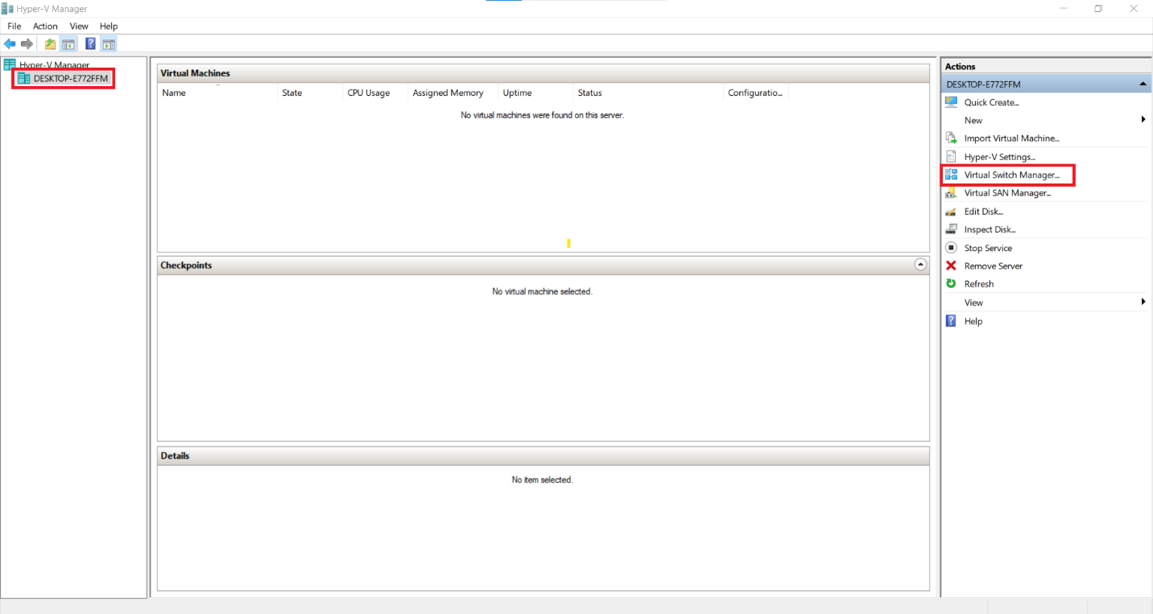

Step 3 - Select External as a connection type and then click on create virtual switch
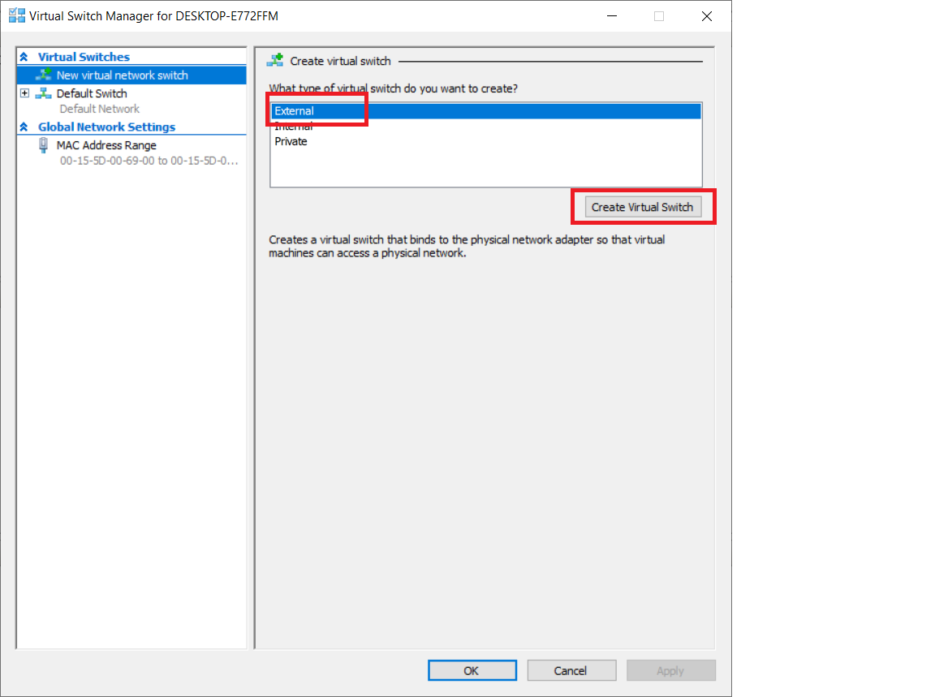
Step 4 - Give name to your virtual switch then click on apply button
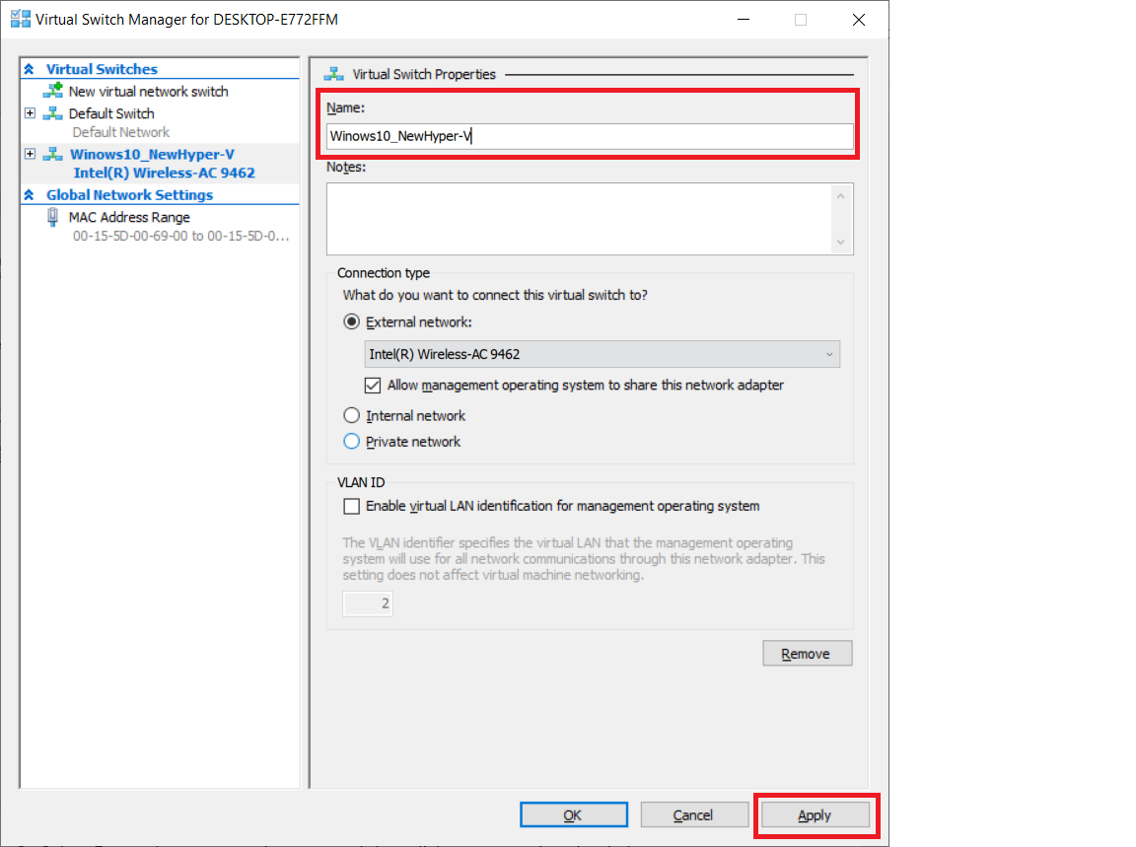
after click on Apply button, it will show warning about our connection click on yes
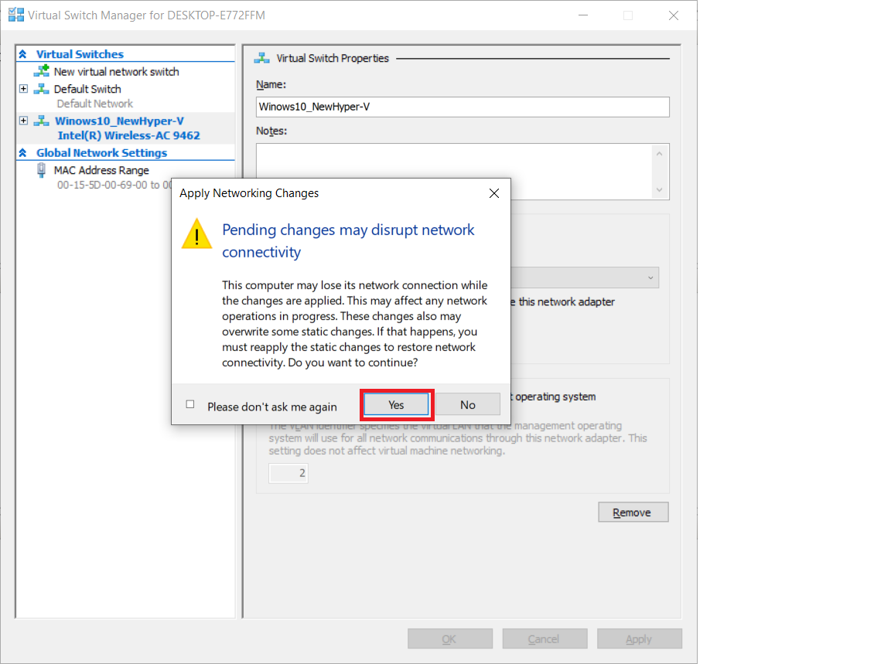
Step 5 - Now right click on server and select new virtual machine
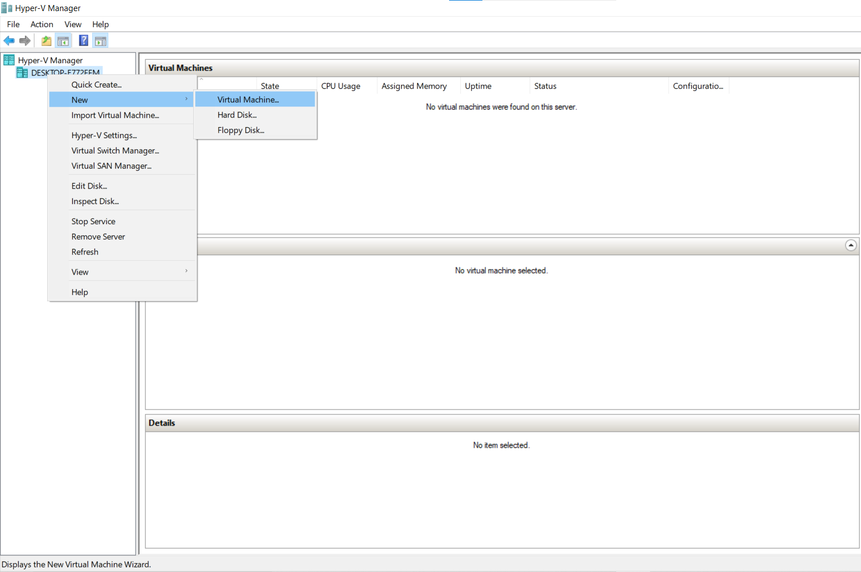

Step 6 - Click on Next button
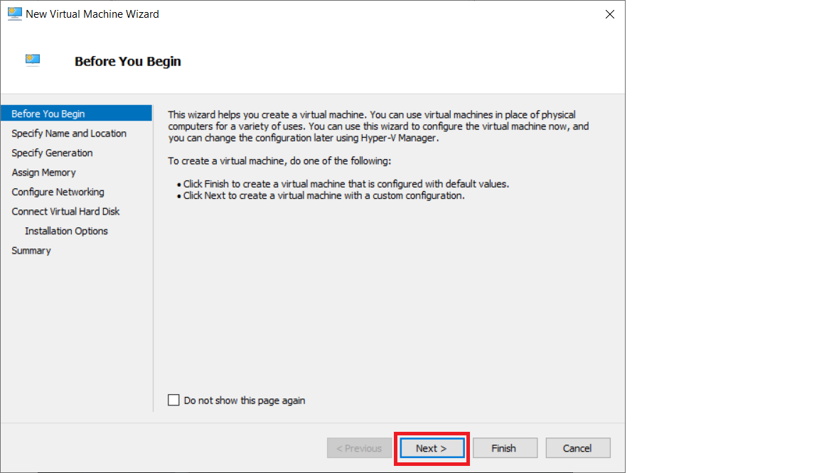

Step 7 - Provide name to virtual machine then click on Next button
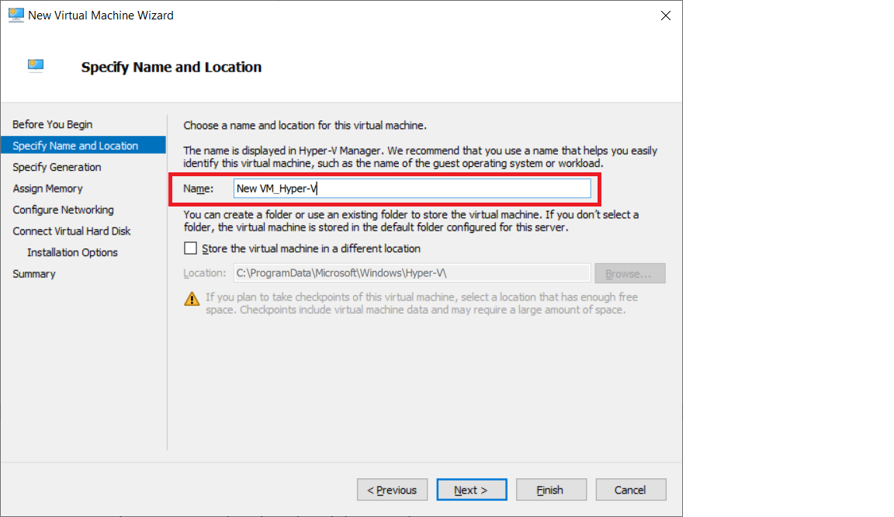

Step 8 - Specify generation: Generation 1
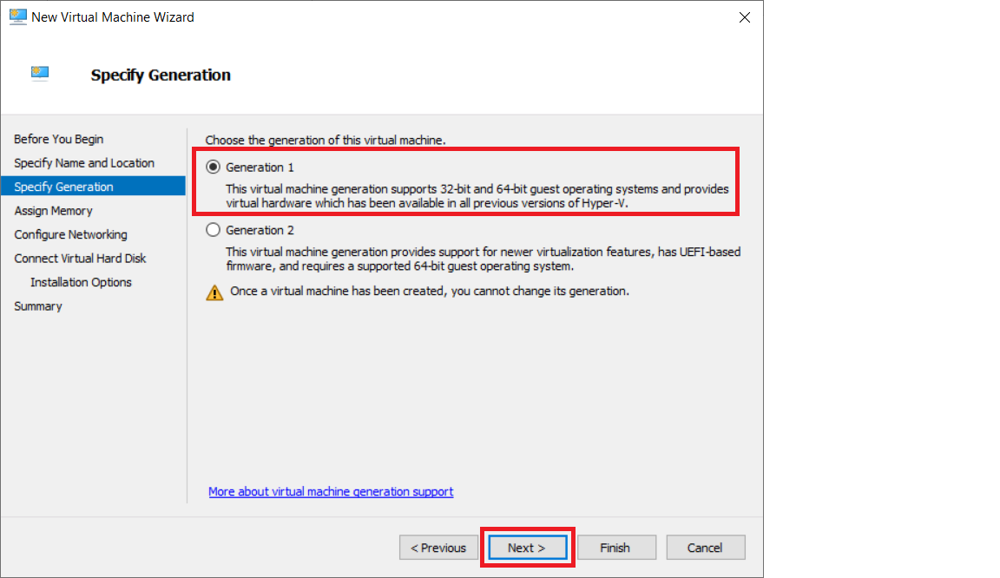

Step 9 - tick on use dynamic memory for this virtual machine
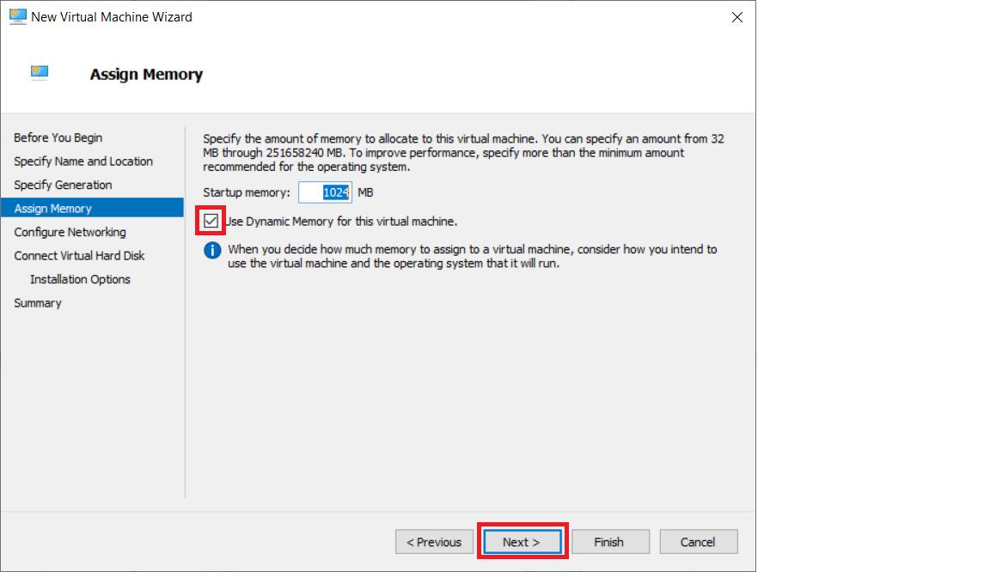

Step 10 - Select switch which we created earlier for our virtual machine from drop-down list and then click on next
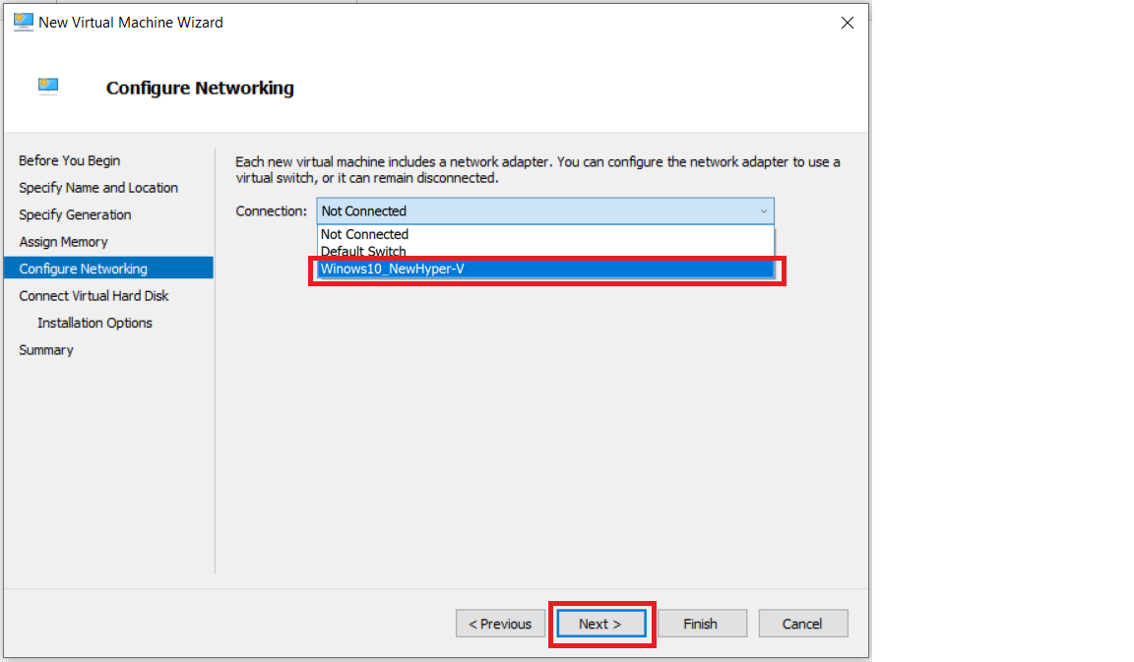

Step 11 - Description of virtual machine and location where it will store virtual machine related files and size require for this machine click on next
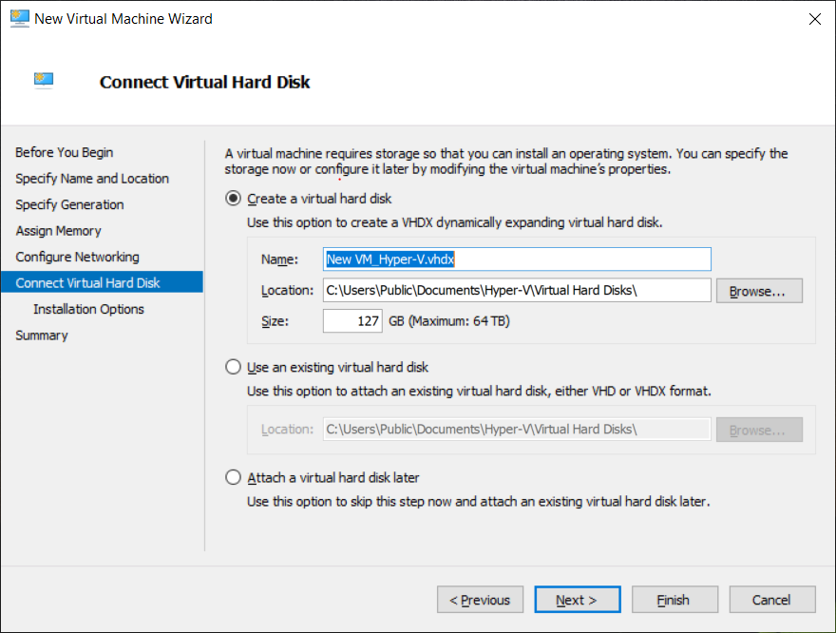

Step 12 - New virtual machine wizard panel will appear, where we will choose operating system which we want to install on virtual machine select install an operating system from boot CD/DVD-ROM and then select Image file(.iso) and browse your OS iso file then click on next button
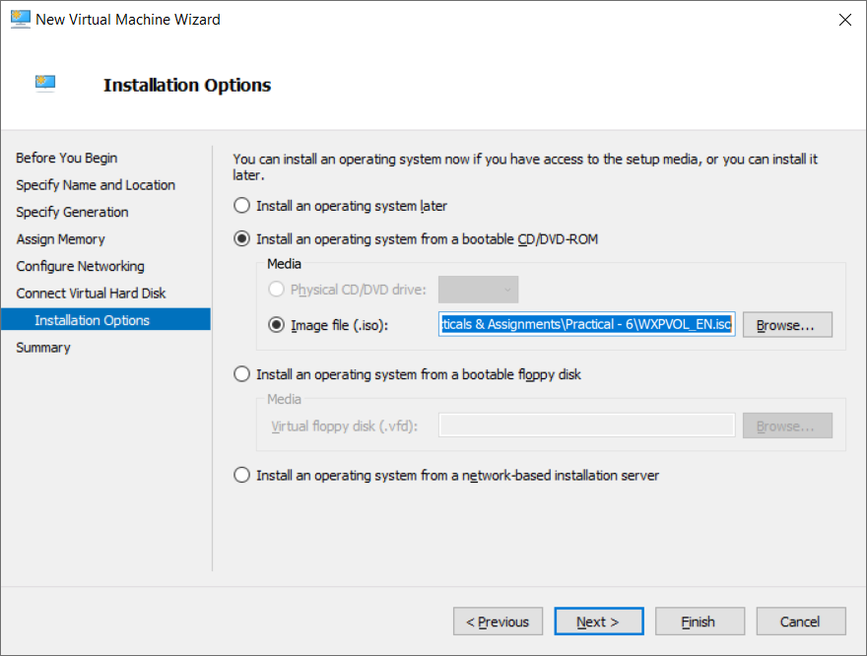
Step 13 - Summary report will be generated about virtual machine then click on Finish button
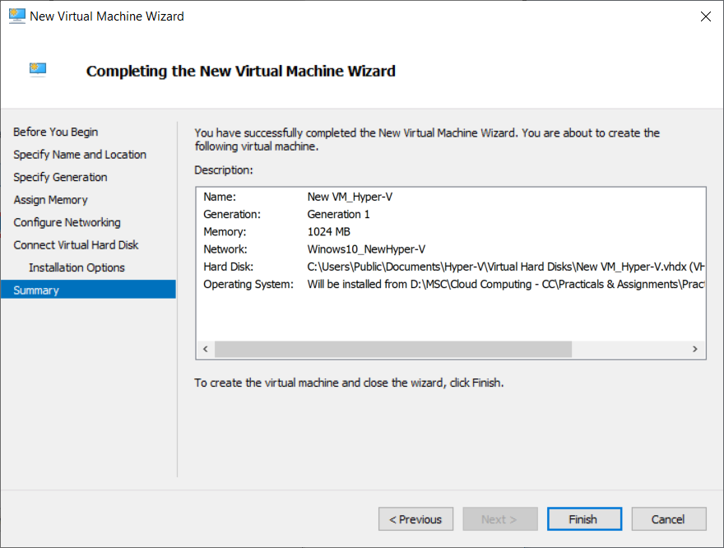

In virtual machine panel your virtual machine will appear which has off state
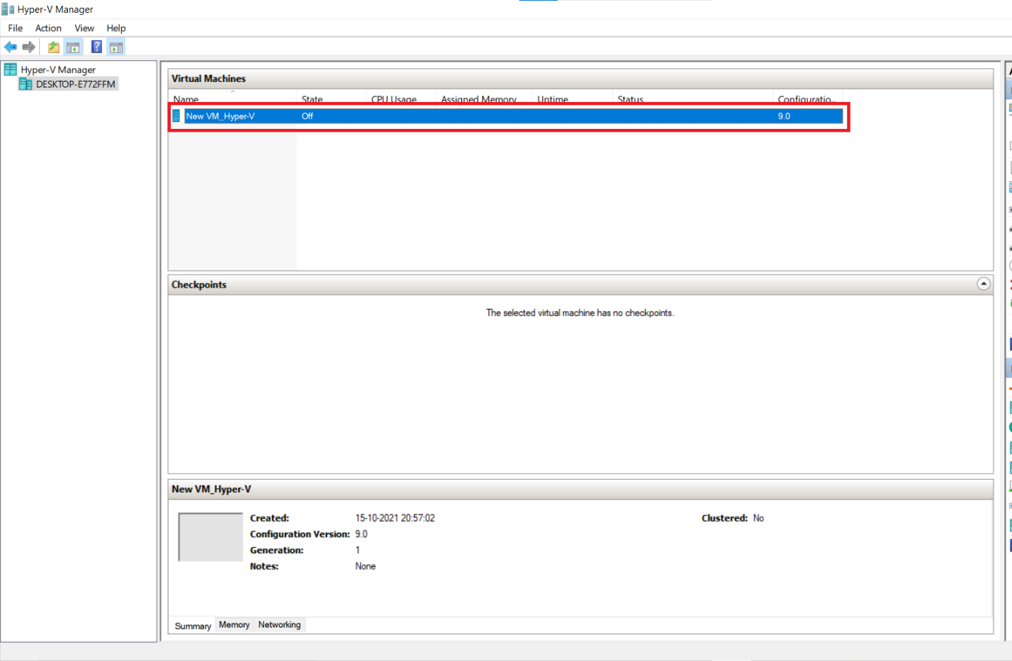

Step 14 - Right click on virtual machine and click on connect option
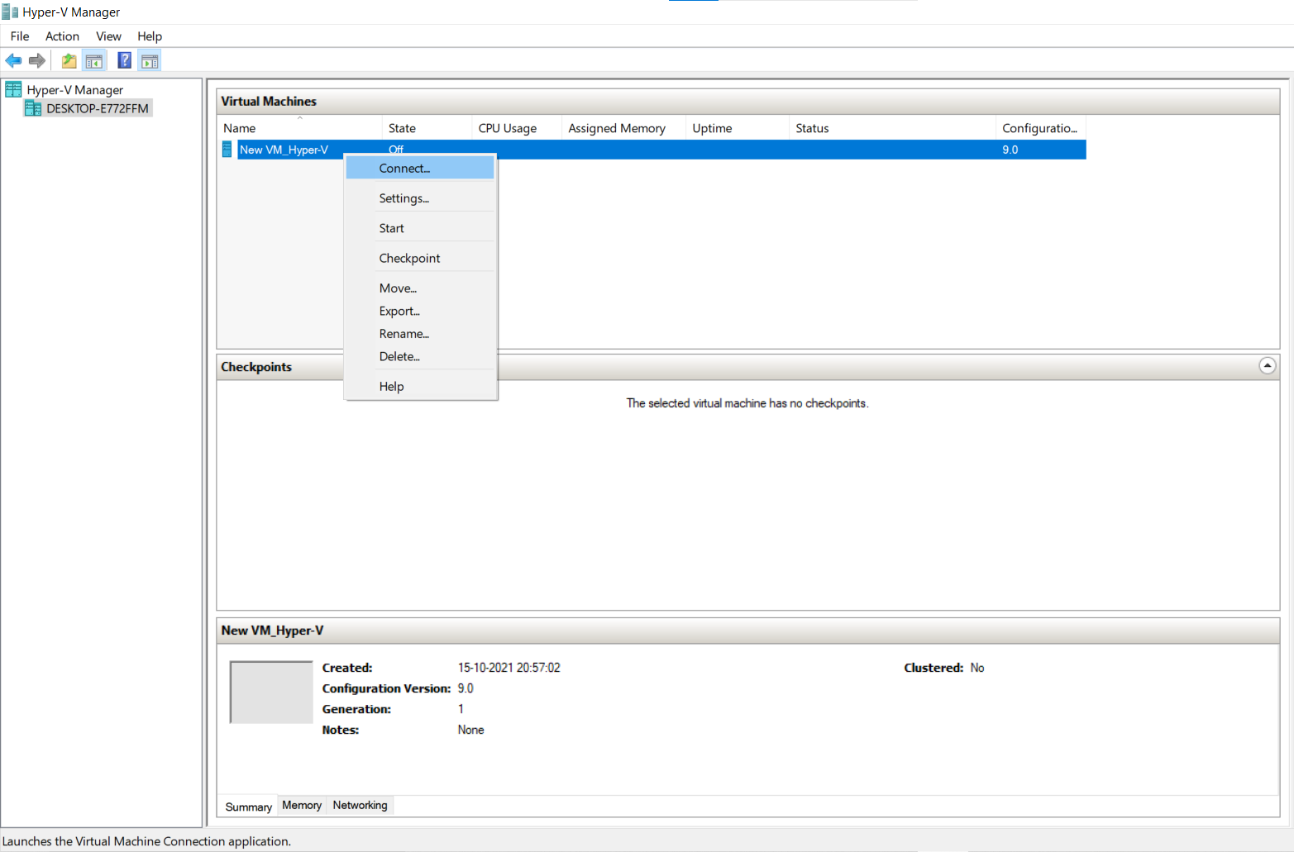

Step 14 - Now turn on virtual machine

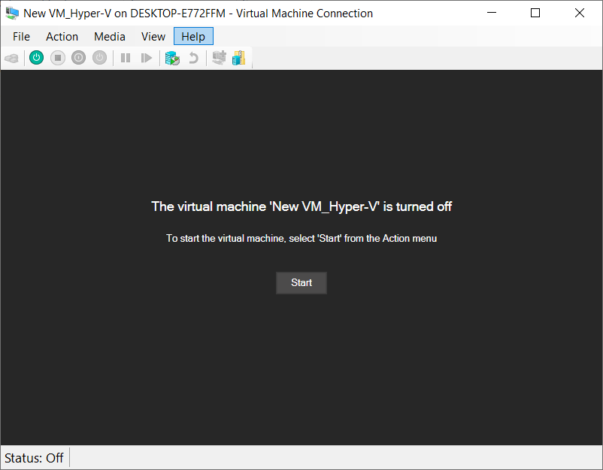

Step 15 - Click Start

Virtual machine will start with below screen
